**DEVELOPMENT OF AN ONLINE LEARNING MANAGEMENT SYSTEM FOR HASSAN USMAN KATSINA POLYTECHNIC, KATSINA STATE**

**BY**

**ABUBAKAR ISIYAKU ABDULLAHI**

**BU/22B/IT/6977**

**SUBMITTED TO THE DEPARTMENT OF COMPUTER SCIENCE, FACULTY OF COMPUTING AND APPLIED SCIENCES,**

**BAZE UNIVERSITY, ABUJA.**

**IN PARTIAL FULFILMENT OF THE REQUIREMENTS FOR THE AWARD OF**

**BACHELOR OF SCIENCE DEGREE IN INFORMATION SYSTEMS MANAGEMENT.**

**FEBRUARY, 2024**

**DECLARATION**

This is to certify that this Thesis entitled Online Learning System, which is submitted by Abubakar Isiyaku Abdullahi in partial fulfilment of the requirement for the award of degree for B.Sc. in Information Technology to the Department of Computer Science, Baze University Abuja, Nigeria, comprises of only my original work and due acknowledgement has been made in the text to all other materials used.

__________________________ _____________________

Almustapha Ado Farouq Date

BU/22B/IT/6871

**APPROVED BY**

………………………....

**Head of Department,**

Department of Computer Science

**CERTIFICATION**

This is to certify that this Thesis entitled Online Learning System, which is submitted by Abubakar Isiyaku Abdullahi In partial fulfilment of the requirement for the award of degree for B.Sc. in Information Technology to the Department of Computer Science, Baze University Abuja, Nigeria is a record of the candidate’s own work carried out by the candidate under my/our supervision. The matter embodied in this thesis is original and has not been submitted for the award of any other degree.

**APPROVAL PAGE**

The project titled "Online Learning System" submitted by Abubakar Isiyaku Abdullahi bearing registration number BU/22B/IT/6977, has been approved by the examination committee for the award of the Bachelor of Science in Information Technology degree at Baze University, Abuja.

By

Dr. Usman Bello Abubakar

Supervisor Date

Assoc Prof. Chandrashekhar Uppin

Head of Department Date

Prof. Peter Ogedebe

Dean, Faculty of Computing and Applied Science Date

Prof. Choji Davou Nyap

External Examiner Date

**DEDICATION**

To my family, whose unwavering love and encouragement have been my anchor in the storm of research challenges. Your belief in me has fueled my determination, and I am forever grateful for your presence in my life. You’ve been my unseen pillars, providing strength when I needed it most.

To my mentors, whose guidance and expertise have shaped my understanding, challenged my assumptions, and ignited my curiosity. Your patience in answering my questions and your passion for knowledge have left an indelible mark on my academic path. I carry your wisdom with me as I venture into uncharted territories.

To my friends, for their unwavering support, understanding, and occasional distractions. Together, we’ve celebrated victories and weathered setbacks. Thank you for being my companions on this research journey. Our shared memories are etched in my heart, and I cherish every moment.

And to the countless individuals whose contributions and insights, whether acknowledged or not, have enriched the foundation upon which this research stands. You’ve shaped my thinking, challenged my assumptions, and broadened my horizons. May this work contribute in some small way to our collective pursuit of knowledge.

**ACKNOWLEDGEMENT**

I would like to express my sincere gratitude and appreciation for your invaluable support and guidance throughout my research project as my supervisor Mr Usman Abubakar. Your expertise, patience, and encouragement have been instrumental in shaping my work and enabling me to achieve my goals.

I would also like to extend my heartfelt thanks to the other lecturers who have contributed to my academic journey. Their insightful feedback, constructive criticism, and encouragement have significantly enriched my research.

I am truly grateful for the time and effort you all have invested in mentoring me. Your dedication to fostering a conducive learning environment has made a lasting impact on my academic growth.

Thank you once again for your unwavering support. I look forward to continuing our collaboration and learning from your expertise in the future.

**ABSTRACT**

Online learning plays a pivotal role. My proposed Learning Management System (LMS) aims to implement online course management in Hassan Usman Polytechnic Katsina. Key features include collaborative spaces, learning paths, assessments, and faculty support. By embracing technology, institutions can create an efficient and engaging online learning environment.

**CHAPTER ONE**

**INTRODUCTION**

**1.1 Overview**

This chapter provides an introduction and background to the proposed learning management system (LMS) for Hassan Usman Katsina Polytechnic. It discusses the motivation for developing an LMS, states the problems an LMS aims to solve, outlines the aims and objectives, significance and potential risks of the project, and the scope and organization of the rest of the report.

**1.2 Background and Motivation**

Hassan Usman Katsina Polytechnic has relied on traditional face-to-face teaching models and manual academic administration processes since its establishment in 2006 (HUK website, 2023). Physical noticeboards, Excel sheets, paper forms, and offline records have typically been used for core academic functions.

However, global education sector transformation provides strong motivation for institutions to integrate digital technologies and online platforms like learning management systems (LMS) into their operations and service delivery. According to studies, LMS usage in higher education helps students achieve better academic results (Asamoah, 2019), while also enabling improved tracking, automation and overall efficiencies for administrators and educators (Tammeorg et al. 2021).

Specifically, only an estimated 15% of institutions currently utilize any form of e-learning systems in Nigeria (Awofala et al. 2022). This highlights the significant room for expansion and value realization possible via LMS adoption. Tailoring a platform to address HUK’s needs provides an opportunity to modernize academic processes, improve outcomes and stakeholder experiences, and potentially increase competitive positioning.

**1.3 Statement of the Problem**

The current academic systems at Hassan Usman Katsina Polytechnic are predominantly manual and paper-based, leading to several challenges including difficulty accessing distributed learning materials for students; communication gaps and lack of collaboration tools between stakeholders; limited assessment administration, grades tracking and student progress monitoring capabilities; unnecessary administrative workload and repetitive manual processes; and an overall sub-optimal academic experience for all parties. These systemic inefficiencies highlight the need for an integrated digital academic management system to improve resource discoverability and accessibility, support seamless multi-party interactions, enable automation of key workflows, provide data-driven analytics and reports, and ultimately enhance teaching, learning and administration across the polytechnic.

**1.4 Aim and Objectives**

The aim of this project is:

To develop an online Learning Management System for Hassan Usman Katsina Polytechnic to improve teaching, learning and academic administration processes.

The objectives include:

1. Automate academic workflows and processes
2. Standardize course structure across the polytechnic
3. Provide a centralized learning portal for students and staff
4. Facilitate instructional resource creation and distribution
5. Implement assessment tools for students performance tracking

**1.5 Significance of the Project**

The development and rollout of a customized learning management system for Hassan Usman Katsina Polytechnic carries profound importance and potential impact on multiple levels - operational, tactical and strategic. By modernizing key academic processes, it can drive step-change improvements in student learning outcomes through enhanced access to resources and assessments tracking. Lecturers and administrators can achieve major productivity gains from automated workflows, saving hours previously spent on manual tasks. Data analytics will generate actionable insights to keep improving overall pedagogical quality. Taken together, these outcomes can markedly strengthen institutional competitiveness in student recruitment and retention, teaching standards, and operational excellence. The project signifies a vital digital transformation milestone for the polytechnic to meet the demands of 21st century teaching and learning excellence.

**1.6 Project Risks Assessment**

Table 1.1 Project Risks Assessment

|  |  |  |  |
| --- | --- | --- | --- |
| **Risk** | **Impact** | **Likelihood** | **Mitigation Strategy** |
| Weak internet infrastructure | High | Medium | Early capacity planning for required bandwidth and devices |
| Resistance to change | Medium | High | Extensive training and engagement with stakeholders |
| Scope creep | High | Medium | Controlled scope management |
| Tight timelines | Medium | High | Iterative development sprints |
| Integration challenges | High | Low | API approach for interoperability |

**1.7 Scope and Organization**

The scope of this project encompasses the analysis, design, development, and implementation of a custom web-based learning management system to support key academic processes for students, lecturers, and administrators at Hassan Usman Katsina Polytechnic. The remaining report documentation is structured across the following core chapters - Chapter 2 expands on requirements gathering and specifications; Chapter 3 details the proposed system architecture and technical design; Chapter 4 elaborates the implementation plan including technologies and phases; Finally Chapter 5 concludes with next steps, recommendations for future enhancements, and key lessons learned from the project. The phased approach allows for an agile methodology focused on iterative delivery to serve institutional stakeholders needs.

**1.8 Definition of Operational Terms**

Learning Management System (LMS) - A software application for administration, documentation, tracking, reporting and delivery of educational courses or training programs.

Academic Workflows - Standardized processes and sequencing of tasks supporting key functions like admissions, scheduling, assessments, and certification.

Automation - Use of technology to complete recurrent tasks previously requiring manual effort to improve efficiency.

Academic Analytics - Data analysis on students activities and performance indicators to provide insights and predict outcomes.

Stakeholders - Key interest groups like students, lecturers, administrators who will directly interact with the system to meet their needs.

Customization - Process of adapting an existing system to match the specific requirements of an organization.

**CHAPTER TWO**

**LITERATURE REVIEW**

**2.1 Introduction**

This chapter provides a review of existing literature related to the concepts, applications, and best practices for learning management systems (LMS) in higher education institutions. It discusses the historical evolution of LMS, summarizes key research findings on the usage and effectiveness of these platforms, and identifies opportunities for customization to meet institutional strategic priorities. The literature review informs the analysis, design and implementation recommendations made in subsequent sections of the project report.

**2.2 Historical Overview**

Learning management systems originated in the 1990s as educational institutions began experimenting with using web technologies and online platforms to complement traditional classroom teaching (Ellis, 2009). Early systems were focused more on course content delivery but over the last two decades, LMS platforms have evolved into comprehensive solutions encompassing course administration, communication tools, assignment hand-in, plagiarism checking, assessments management, analytics dashboards, and integration capabilities with third-party academic applications (Watson & Watson, 2007).

Modern cloud-based LMS systems are highly customizable to institutional needs and mobile-compatible to match access trends. Leading proprietary solutions include Blackboard, Canvas, Moodle, Schoology, whereas open-source options like Moodle and Canvas are also popular. Recent developments use machine learning and analytics to provide adaptive learning experiences personalized to each student strengths and weaknesses to improve outcomes.

**2.3 Related Works**

Multiple studies on LMS implementations validate their advantages and effectiveness for students, educators and academic institutions. Asamoah (2019) found significant improvements in student grades, satisfaction, and perceived productivity with LMS use compared to traditional methods. Instructors reported advantages like easier assignment management, better reproductive use of content, and tracking student progress. Damşa et al. (2021) measured time savings for educators from automatic grading workflows, plagiarism checking, and reuse of course templates in subsequent terms.

However, challenges like technical issues, training overheads, integration complexity and change resistance from users are also highlighted for consideration during platform selection and rollout planning (Aldiab et al. 2022). Hence understanding key user requirements and customization opportunities is an important success factor (Tammeorg et al. 2021) as discussed further in the next chapter.

Asamoah (2019) found that LMS usage led to significant improvements in student performance, satisfaction, and perceived productivity compared to traditional teaching methods. Instructors reported advantages like easier assignment creation/distribution, reusable content, remote learning support, and data-driven insights to adjust teaching strategies. Ricoy et al. (2022) surveyed over 700 students and found over 87% felt an LMS was useful for improving access to materials, communication and needed academic resources.

On the institutional side, administrators gained automation for key processes like enrollment, assessments, and certification. This enabled improved quality control, auditing and reduced manual workload (Baloyi, 2014). Costa et al. (2012) estimated potential productivity gains to recoup LMS investment in under 3 years in their cost-benefit model case study.

However, studies have also examined implementation challenges experienced. Poor interface design and technical glitches were top complaints impacting user adoption and satisfaction (Aldiab et al. 2022). Ssekakubo et al. (2013) identified resistance to change, lack of institutional support and perceptual barriers regarding eLearning effectiveness amongst factors deterring LMS penetration. Staff training costs are also highlighted, but faculty onboarding processes involving collaborative design sprints can offset these concerns and drive engagement (Damşa et al. 2021).

Key recommendations include extensive planning for integration capabilities, accessibility needs and core use cases prioritization based on user segments (Tammeorg et al. 2021). Iterative rollouts allow course corrections after feedback cycles. Understanding unique institutional requirements is vital for long-term LMS sustainability and leveraging possibilities beyond just digitizing traditional models (Rienties et al. 2022).

Al-Busaidi and Al-Shihi (2010) found that system quality factors like usability, reliability, responsiveness and flexibility were top drivers for instructors. Features allowing content reuse across courses and ease of grading assessments also rated highly. For students, information quality dimensions like relevance, understandability, and ability to meet academic goals were critical. Standard LMS platforms may need customization and integrations to tailor to these expectations.

User engagement from early design stages can reveal unique preferences and process workflows to inform system requirements (Islam et al. 2022). Ongoing co-creation also enables buy-in and change management. Training and onboarding that aligns LMS features to actual teaching or learning needs cement adoption.

Assessing technological readiness and organizational culture aspects also prevents barriers. Leadership direction and resource allocation to guide transition while accommodating initial learning curves encourage persistence in usage (Aldiab et al. 2021). Incremental system rollouts allow familiarity before adding complexity.

Al-Busaidi (2012) found functionality, reliability and usability were critical expectations regardless of platform type. Open-source systems like Moodle were perceived as more customizable to institutional needs and integration ready with existing IT infrastructure which aided acceptance. But some proprietary systems scored higher on user-friendliness and stability.

Klobas and McGill (2010) highlight that the effectiveness of either LMS model depends not just on features but the quality of integration support, change management and user training provided during implementation. Open-source platforms benefited from wider community developer ecosystems enabling agile enhancements but relied more on inhouse technical skills. Proprietary LMS vendors offered full IT support services but at a recurring licensing cost premium. The complementary capabilities needed for sustainable deployment must be evaluated.

Organizations also displayed preference biases - smaller institutions leaned towards open-source options for tighter budget while larger universities gravitated to market leading proprietary LMS believing the stability and support outweighed upfront costs (Weaver et al., 2008). But hybrid models adopting the best of both platforms are an emerging option. The optimal LMS solution is contingent on multiple relative factors.

Artificial intelligence and machine learning are enabling more responsive personalization of learning experiences tailored to individual pace and need - adaptive content, smart testing recommendations, predictive analytics to pre-empt academic issues etc (Shahiri & Husain, 2021). Augmented/virtual reality solutions are being integrated for more engaging interactive learning modules spanning diverse topics and formats.

With more affordable devices, cloud infrastructure and 5G, remote live streaming of specialized teaching sessions can connect external expert instructors or far-flung student groups into integrated Omni-channel learning environments (Chinese, 2021). Blockchain platforms also facilitate building tamper-proof competency records and micro-credentials critical for life-long learning objectives (Ocheja et al. 2022).

However these emerging technologies layer on additional adoption challenges regarding skills, support and service management relative to institutional readiness (Raza, 2022). But the innovation opportunities and digitally enriched multi-modal academic experiences possible make the modernization imperative worth pursuing (Tlili et al. 2022). Analyzing both established and emerging technologies can inform strategic LMS roadmapping priorities.

Abdellatief et al. (2022) surveyed over 300 university students to identify most preferred LMS interface features - simplicity, logical information flow, visually appealing elements, consistency across device access modes. Excessive features caused confusion. Personalization to display most relevant tools and content also rated highly.

Ease of navigation, clear labeling, and common convention based layouts reduced cognitive load. Instant feedback and status visibility on submitted actions provided assurance. Summarized content with expand/collapse helped focus attention. Automated recommendations and notifications kept users in workflow. Offline access enabled continuity for limited connectivity.

Beyond interface design, a positive first-time user experience through self-service tutorials, responsive in-app support, and ability to test the platform risk-free cemented ongoing engagement. Continuous user testing cycles enable rapid refinements towards optimal design thinking (Martin et al. 2022). Prioritizing use cases aligning high value to users versus technical complexity guides system evolution.

Islam et al. (2021) developed an integrated model emphasizing "soft issues" like commitment building, training and incentives for user buy-in as equal enablers of LMS success alongside technical robustness. Leadership involvement in articulating strategic vision linked to pedagogical and operational improvements from the platform cemented persistence in usage despite inevitable initial adoption pains.

Ongoing participative decision making also enables course corrections responding to emergent needs. Tammeorg et al. (2021) concludes extensive early consultation and collaborative design of academic processes and system requirements minimizes disruptiveness during implementation. Proactively addressing accessibility barriers and attitudes preventing technology embracement through this engagement reduces resistance.

Post-implementation support services to resolve troubleshooting issues in a timely manner also improves learner satisfaction and system stickiness (Aldiab et al. 2021). Allocating dedicated personnel as campus advocates guiding the transition is considered impactful. Sustained stakeholder involvement is thus essential before, during and after LMS deployments.

**2.4 Comparative Analysis**

Table 2.1 Comparative Analysis of the Related Works

|  |  |  |  |
| --- | --- | --- | --- |
| **Study** | **Methods/Approach** | **Strengths** | **Weaknesses** |
| Asamoah (2019) | Quantitative survey and data analysis | - Significant improvements in student grades, satisfaction, and productivity  - Easier assignment management and content reuse  - Data-driven insights for teaching adjustments | - Technical issues and training overheads  - Resistance to change from users |
| Damşa et al. (2021) | Quantitative analysis and case study | - Time savings for educators from automatic grading and course template reuse  - Improved quality control and reduced manual workload for administrators | - Technical issues and training overheads  - Resistance to change from users |
| Ricoy et al. (2022) | Survey and qualitative analysis | - Improved access to materials and communication  - Positive impact on student satisfaction  - Useful for accessing academic resources | - Poor interface design and technical glitches  - Resistance to change and lack of institutional support |
| Baloyi (2014) | Case study and cost-benefit analysis | - Automation of key processes and improved quality control  - Reduced manual workload for administrators  - Potential productivity gains for institutions | - Lack of institutional support and resistance to change  - Staff training costs |
| Costa et al. (2012) | Cost-benefit analysis and case study | - Potential productivity gains to recoup LMS investment  - Improved quality control and auditing  - Reduced manual workload for administrators | - Lack of institutional support and resistance to change  - Staff training costs |
| Ssekakubo et al. (2013) | Survey and qualitative analysis | - Identified factors deterring LMS penetration  - Perceptual barriers regarding eLearning effectiveness | - Resistance to change and lack of institutional support  - Perceived lack of effectiveness of eLearning |
| Al-Busaidi and Al-Shihi (2010) | Survey and qualitative analysis | - Identified key system quality factors for instructors and students  - Content reuse and ease of grading assessments | - Lack of institutional support and resistance to change  - Poor interface design |
| Rienties et al. (2022) | Literature review and qualitative analysis | - Emphasizes the importance of understanding unique institutional requirements  - Long-term sustainability and leveraging possibilities beyond traditional models | - Lack of customization and focus on digitizing traditional models  - Limited implementation details |

**2.5 Summary**

This chapter provides a literature review of learning management systems (LMS) in higher education. It discusses the historical evolution of LMS, their key features and functionalities, and their effectiveness in improving student outcomes and administrative processes. The chapter also highlights the advantages and challenges associated with LMS implementation, including customization opportunities and the importance of understanding user requirements.

**CHAPTER THREE**

**REQUIREMENTS ANALYSIS AND DESIGN**

**3.1 Overview**

This chapter focuses on gathering and analyzing requirements, as well as formulating the system design for the proposed online Learning Management System (LMS) tailored for Hassan Usman Katsina Polytechnic (HUKPOLY). Through consultations with key institutional stakeholders, comprehensive functional and non-functional requirements have been captured. To depict the analysis and proposed system design, use case diagrams, workflow diagrams, data models and interface prototypes have been developed.

**3.2 Methodology**

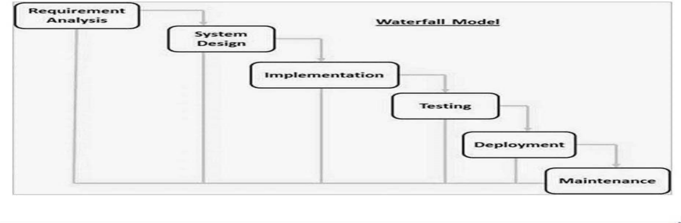The main software development approach selected is the iterative and incremental model allowing collaborative design sprints. This provides flexibility to continuously gather feedback from students, instructors and administrators on prioritized features and make adjustments based on real institutional usage patterns. The process involves modular software builds with the most critical academic workflows and components first. Additional functionality can be added in phased releases over multiple development cycles.

Figure 3.1 Waterfall Model (Wikipedia, 2013)

**3.3 Tools and Technologies**

The LMS will utilize a MERN (MongoDB, Express.js, ReactJS, Node.js) technology stack for building an accessible cloud-hosted web application. Responsive mobile-friendly interfaces will be implemented through ReactJS. MongoDB provides schema-flexible document storage. Machine learning APIs from TensorFlow and Azure Cognitive Services will enable intelligent functionality over time e.g. plagiarism checking.

**3.4 Ethical Considerations**

Key ethical aspects considered include:

1. Data privacy, security and transparent policies
2. Accessibility and inclusion requirements
3. Fairness, accountability in algorithmic recommender systems
4. Validity, integrity checks in automated grading/assessments
5. Ethical use of analytics data to improve student experiences

Appropriate technical and policy controls will be instituted to address these.

**3.5 Requirements Analysis**

**3.5.1 Functional Requirements**

Table 3.1 Functional Requirements

|  |  |  |  |  |
| --- | --- | --- | --- | --- |
| **ID** | **User Segment** | **Requirement** | **Description** | **Priority** |
| FR1 | Student | View course materials | Ability to view lecture slides, notes, tutorial videos, reading links and other learning content for enrolled courses | High |
| FR2 | Student | Attempt assessments | Take quizzes, assignments, exams and view scored results | High |
| FR3 | Student | Track academic progress | View personal performance dashboards showing test scores, assignment grades, standing based on course expectations | High |
| FR4 | Student | Participate in forums | Engage in discussions by posting questions, responses and share resources with classmates under each course | Medium |
| FR5 | Instructor | Author course content | Create and upload learning materials like documents, slides, videos, web links for each course | High |
| FR6 | Instructor | Assess students | Compose assessment questions, hosted timed exams, create assign deliverables, allocate grades/marks | High |
| FR7 | Instructor | Student tracking | Monitor key engagement and performance metrics at individual/cohort level | Medium |
| FR8 | Administrator | Student enrollment | Digitize registration details, manage program allotments and class allocations | High |
| FR9 | Administrator | Access control | Create and manage user accounts, privileges and system roles | High |
| FR10 | Administrator | Institutional reporting | Leverage analytics dashboard spanning multiple courses/programs for insights | Medium |

**3.5.2 Non-Functional Requirements**

Table 3.2 Non-Functional Requirements

|  |  |  |  |
| --- | --- | --- | --- |
| **Category** | **Requirement** | **Description** | **Priority** |
| Usability | Intuitive interface | Simple, consistent and easy-to-use interface across student, instructor and admin modules | High |
| Usability | Responsiveness | Uniform experience across desktop and mobile devices with auto-adjusted interfaces | Medium |
| Performance | Response time | Pages and submissions processing should occur in under 5 seconds for 98% of transactions | High |
| Availability | Uptime | Platform available 24x7 with minimum 99% uptime | High |
| Scalability | Concurrent users | System able to handle 500 concurrent logged in users with no degradation in performance | Medium |
| Scalability | Data capacity | Database and object storage scaled to handle volumes from 5000+ students | Medium |
| Security | Authentication | Validate user identity through passwords and MFA before granting system access | High |
| Security | Data encryption | Encrypt stored pupil information and transmitted content using AES 256-bit encryption | High |
| Security | Access control | Granular access policies on functionality exposure based on user role | Medium |
| Standards | Interoperability | Support for open API integration with complementary academic systems | Low |
| Standards | Accessibility compliance | Web Content Accessibility Guidelines (WCAG) 2.1 level AA standards adherence | Medium |

**3.6 System Models and Diagrams**

**3.6.1 Application Architecture**

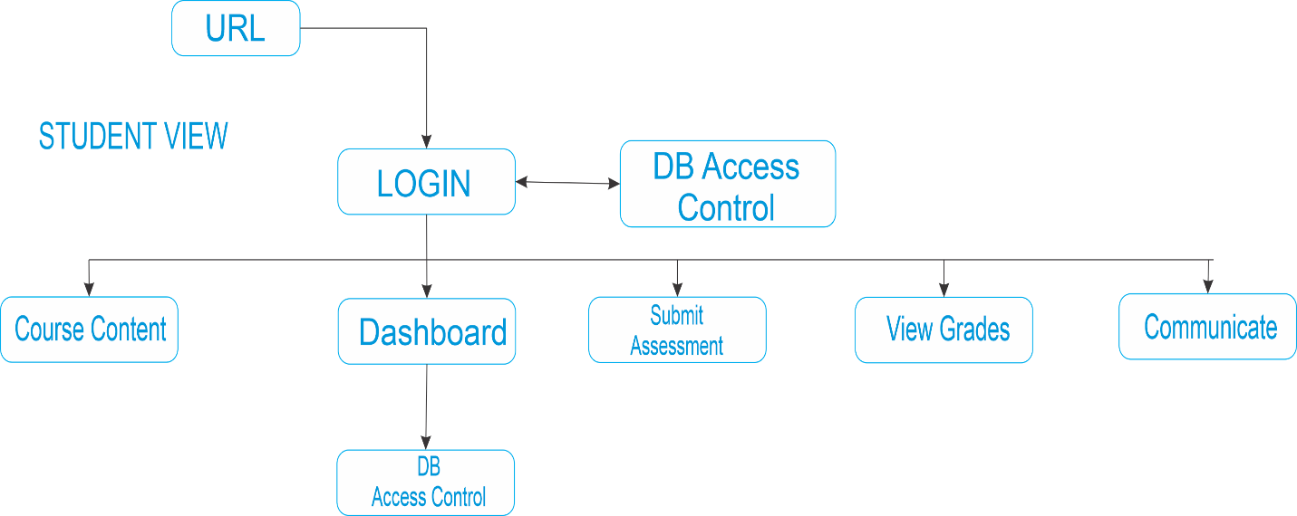

Figure 3.2 Application Architecture Diagram (Student)

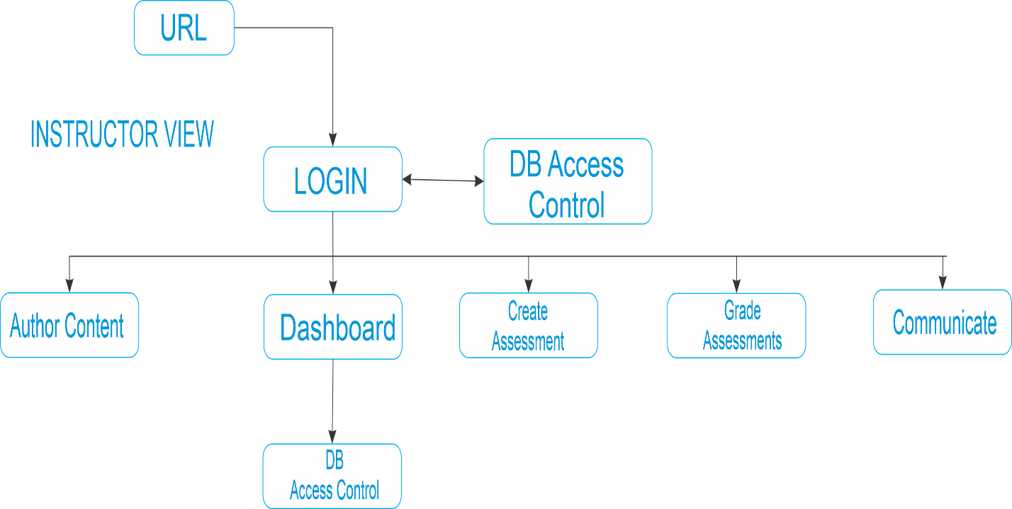

Figure 3.3 Application Architecture Diagram (Instructor)

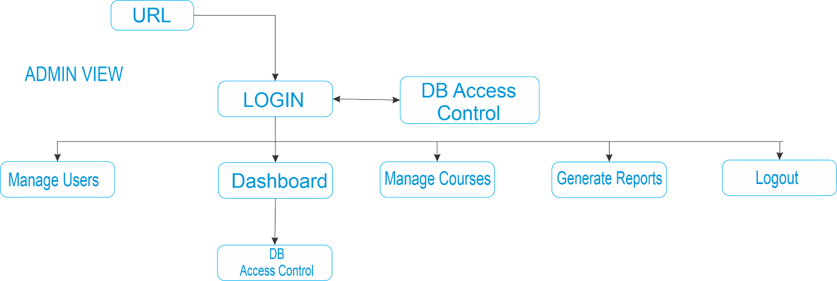

Figure 3.4 Application Architecture Diagram (Admin)

**3.6.2 Use Case Diagram**

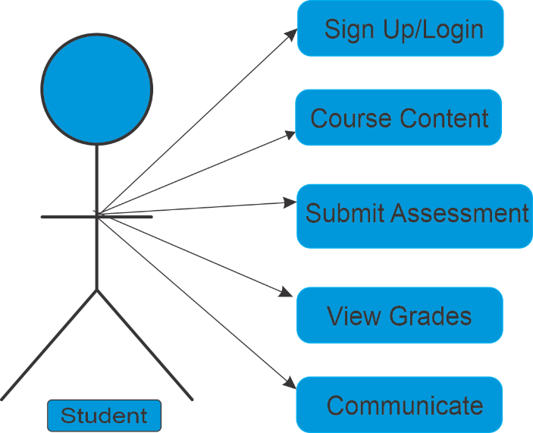

Figure 3.5 Use Case Diagram (Student)

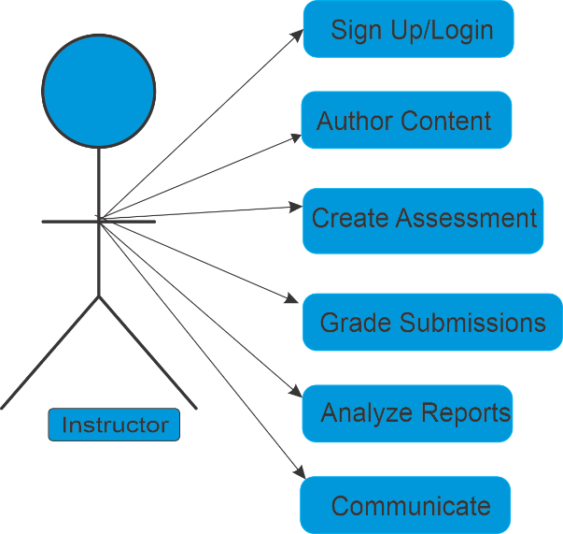

Figure 3.6 Use Case Diagram (Instructor)

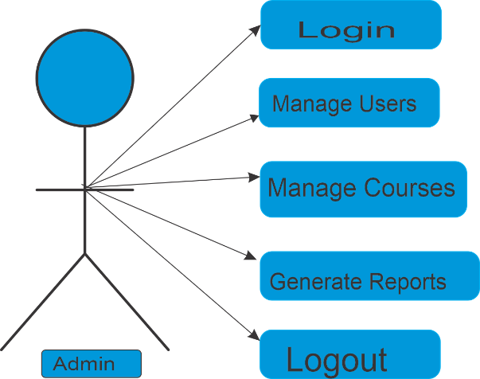

Figure 3.7 Use Case Diagram (Admin)

**3.6.3 Entity Relationship Diagram**

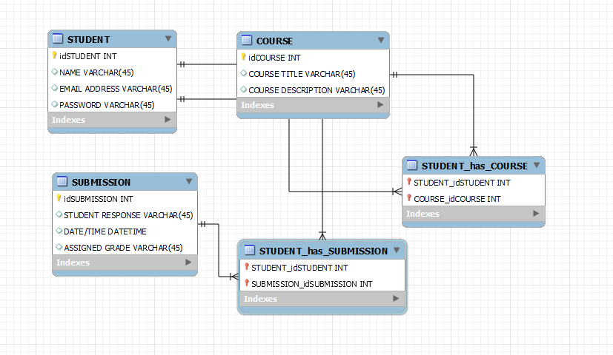

Figure 3.8 Entity Relationship Diagram

**3.6.4 Activity Diagram**

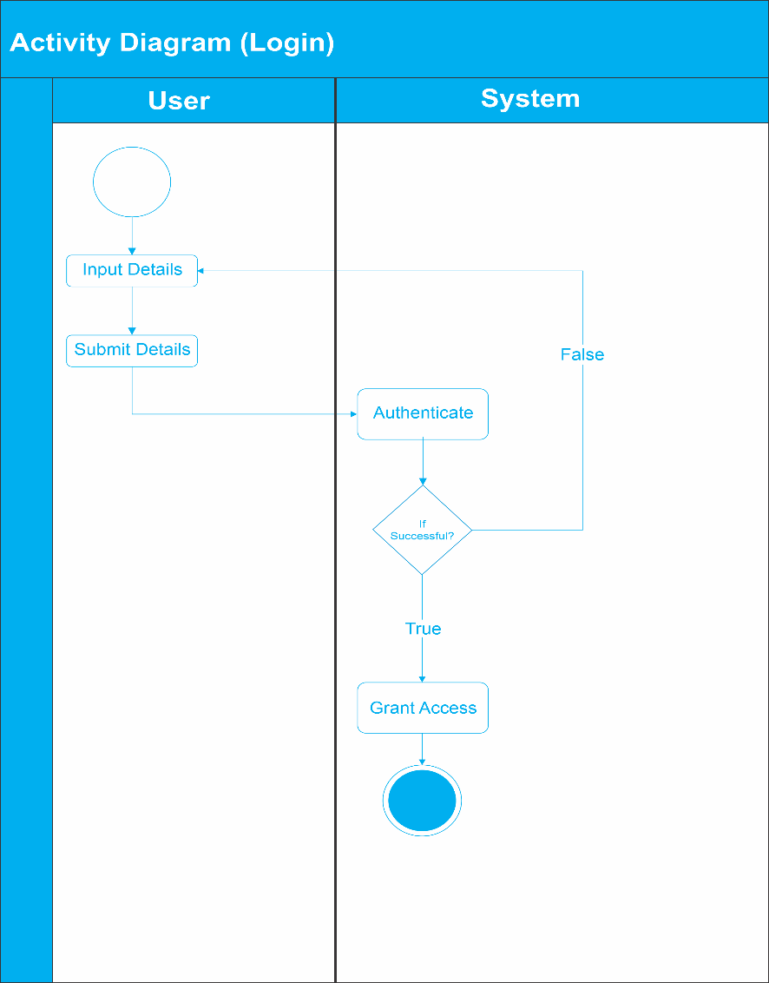

Figure 3.9 Activity Diagram-Login

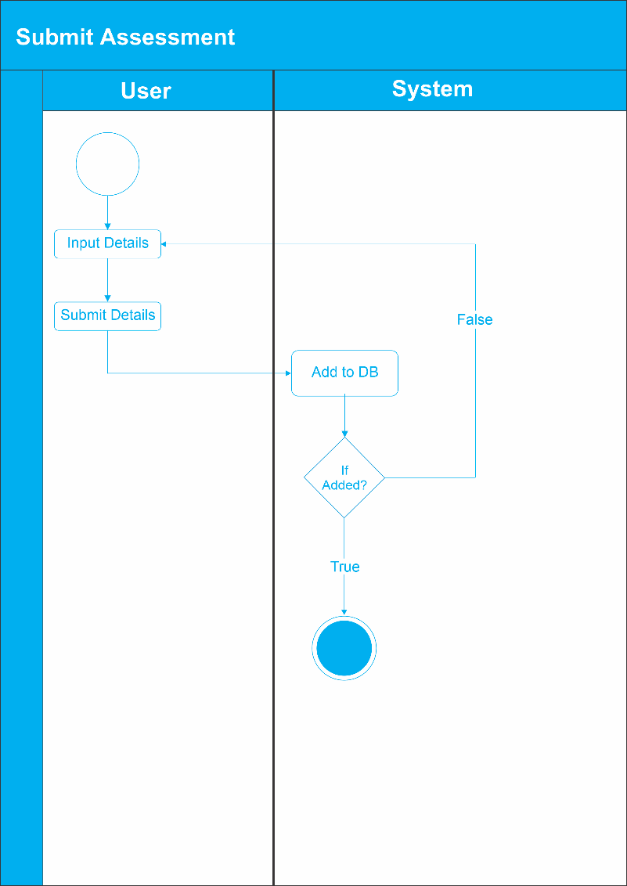

Figure 3.10 Activity Diagram-Submit Assessment

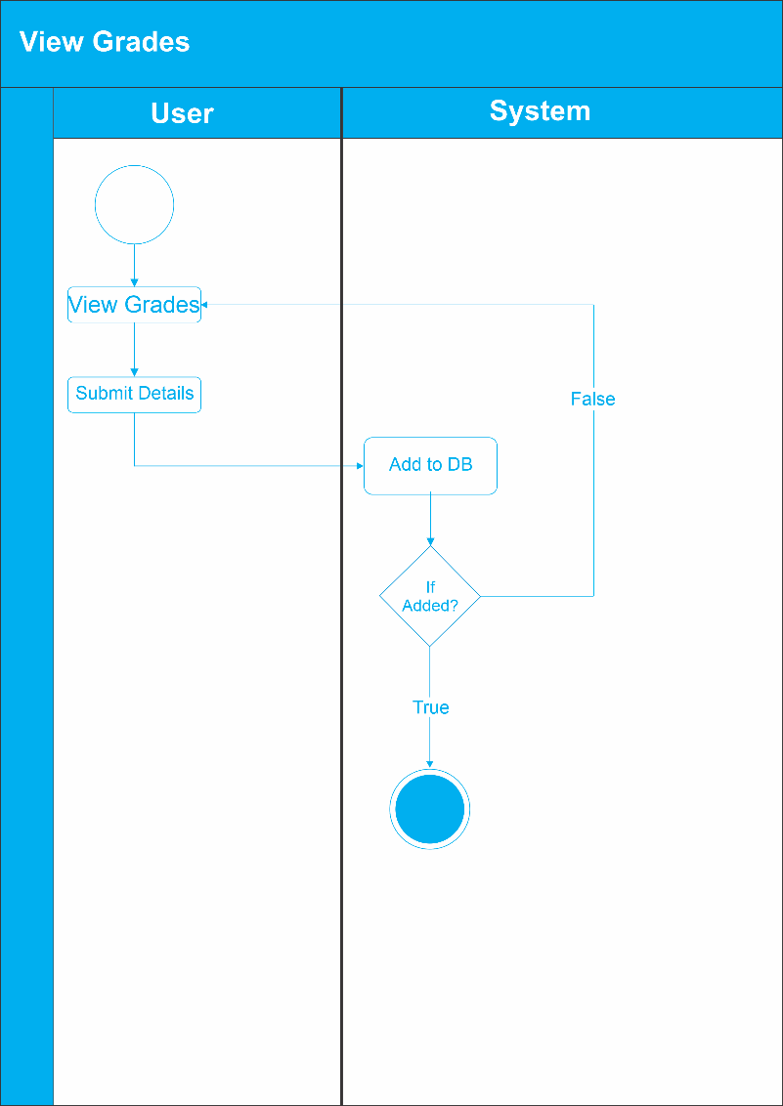

Figure 3.11 Activity Diagram- View Grades

**3.9 User Interface Design**

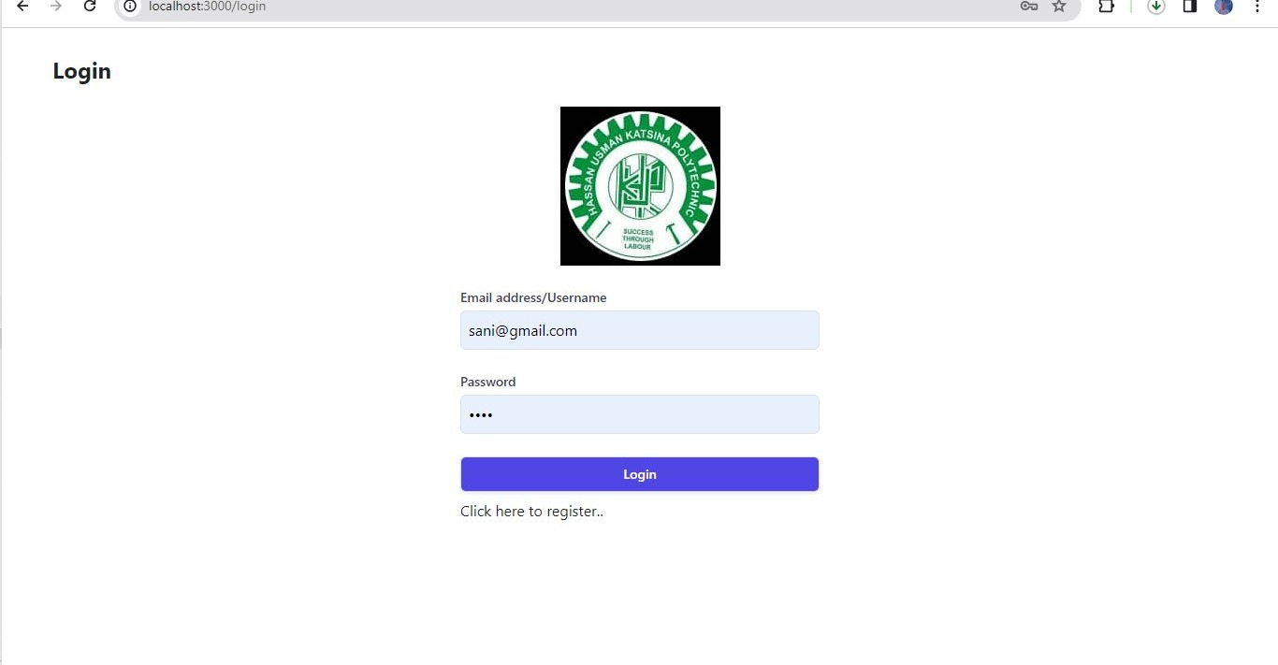

Figure 3.12 Login

The login process begins with the user accessing the login page of the Learning Management System. Figure 3.12 illustrates the login interface where the user enters their credentials, including a username and password. After entering the credentials, the user clicks the "Login" button. The system then verifies the provided credentials against the stored user data in the database. If the credentials are valid, the user is granted access to the system and proceeds to the main dashboard. However, if the credentials are invalid, an error message is displayed to indicate that the login attempt has failed.

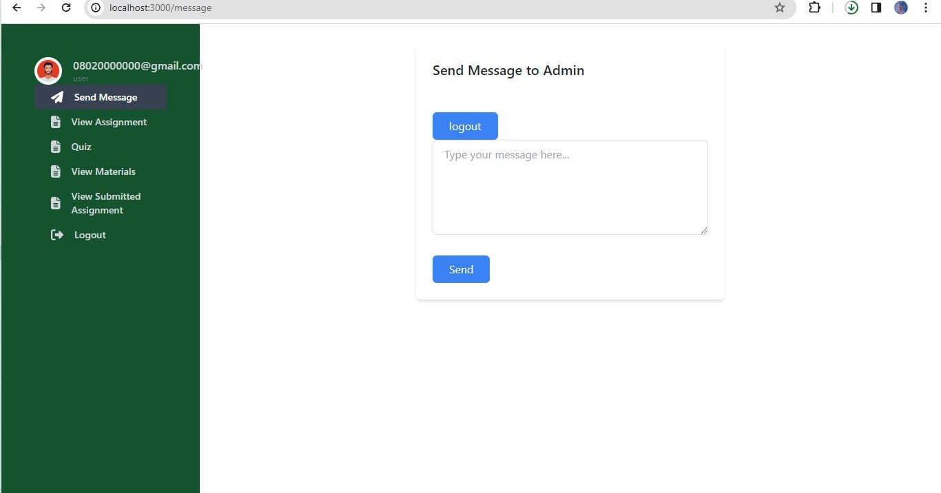

Figure 3.13 Send Message

Once logged in, the user can navigate to the "Messages" section to send a message. Figure 3.13 depicts the interface where the user can compose and send a message. The user enters the recipient's details, such as the username or email address, in the "To" field. The user writes the message content in the designated text area. After composing the message, the user clicks the "Send" button. The system sends the message to the recipient and updates the message notification for both the sender and recipient.

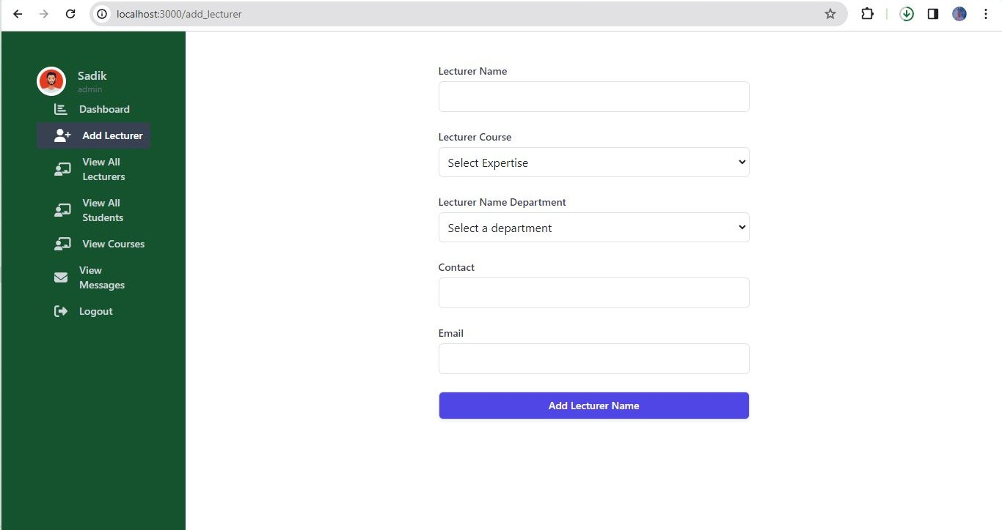

Figure 3.14 Add Lecturer (Admin)

An admin user can select the "Add Lecturer" option in the main dashboard to add a new lecturer. Figure 3.14 displays the interface where an admin can input the relevant details of the new lecturer, such as name, email, and contact information. After providing the details, the admin clicks the "Add" button. The system adds the new lecturer to the system and assigns appropriate permissions.

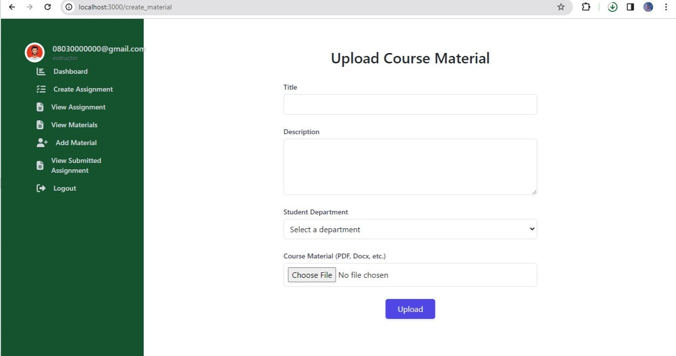

Figure 3.15 Add Material (Instructor)

The instructor can select the "Add Material" option in the main dashboard to add course materials. Figure 3.15 displays the interface where an instructor can add material details, such as the title, description, and associated course. The instructor can upload files, such as lecture slides, handouts, or reference materials. After providing the details and uploading the files, the instructor clicks the "Add" button. The system saves the material and makes it accessible to the students.

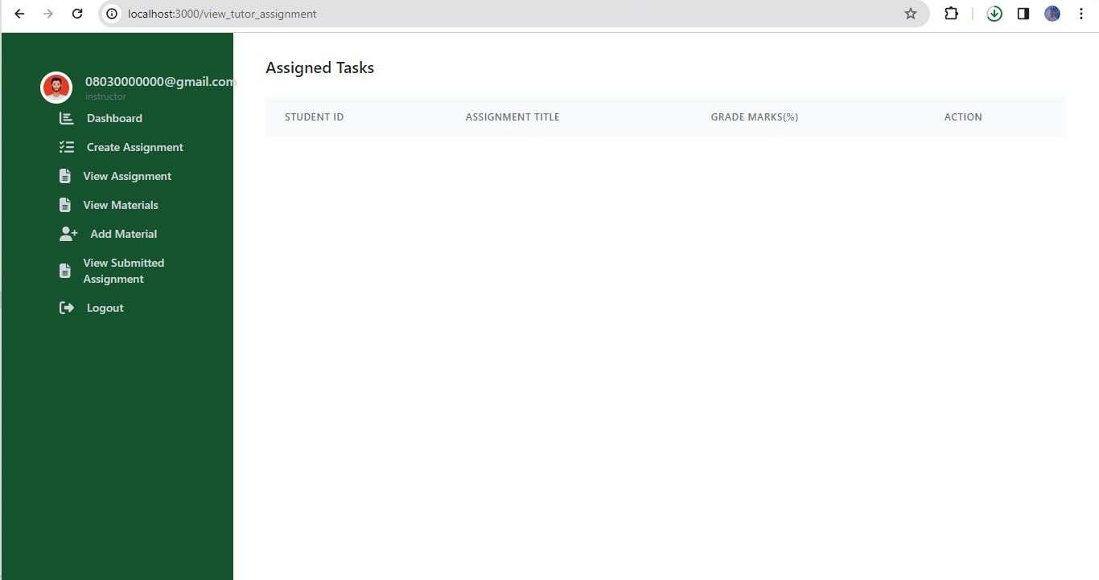

Figure 3.16 View Assignment (Instructor)

To view assignments, the instructor can select the "View Assignment" option in the main dashboard. Figure 3.16 illustrates the interface where an instructor can see a list of assignments with details such as the title, due date, and number of submissions. By clicking on a specific assignment, the instructor can view the submissions and evaluate them as necessary.

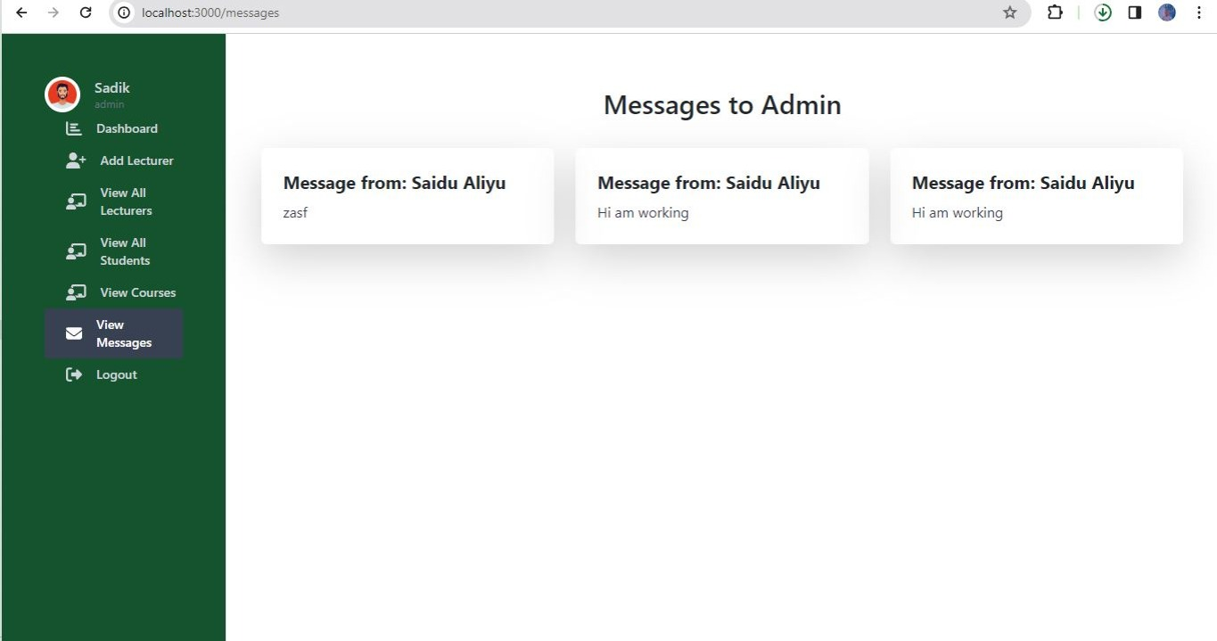

Figure 3.17 View Messages

In the main dashboard of the Learning Management System, the user can select the "Messages" option. Figure 3.17 illustrates the interface where a user can view received messages. The interface displays a list of received messages, organized by sender, subject, and date. The user can quickly scan through the list to identify the messages of interest. By clicking on a specific message, the user can access its content and read the message in detail. The interface may also provide options to reply to the message or perform other actions, such as marking the message as read or deleting it. Users can navigate between different messages using navigation buttons or pagination if there are multiple pages of messages. This allows users to efficiently manage their messages and stay updated with important communications within the Learning Management System.

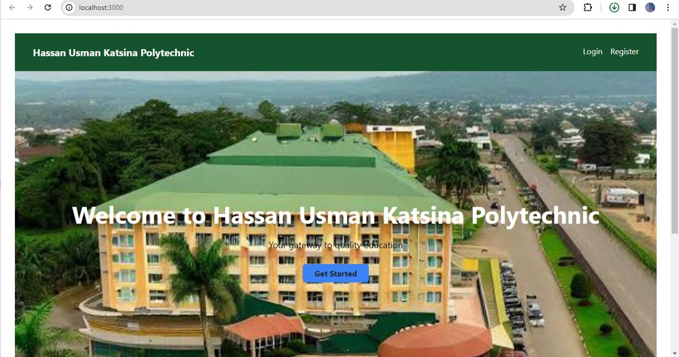

Figure 3.18 Home Page

When users log in to the Learning Management System, they are directed to the home page or main dashboard. The home page serves as the central hub where users can access various features and functionalities of the LMS. Figure 3.18 illustrates a hypothetical home page interface for the LMS. The home page provides an overview of important information and activities related to the user's courses and interactions within the system. It may include components such as a personalized welcome message, upcoming deadlines, notifications, course announcements, and a navigation menu.

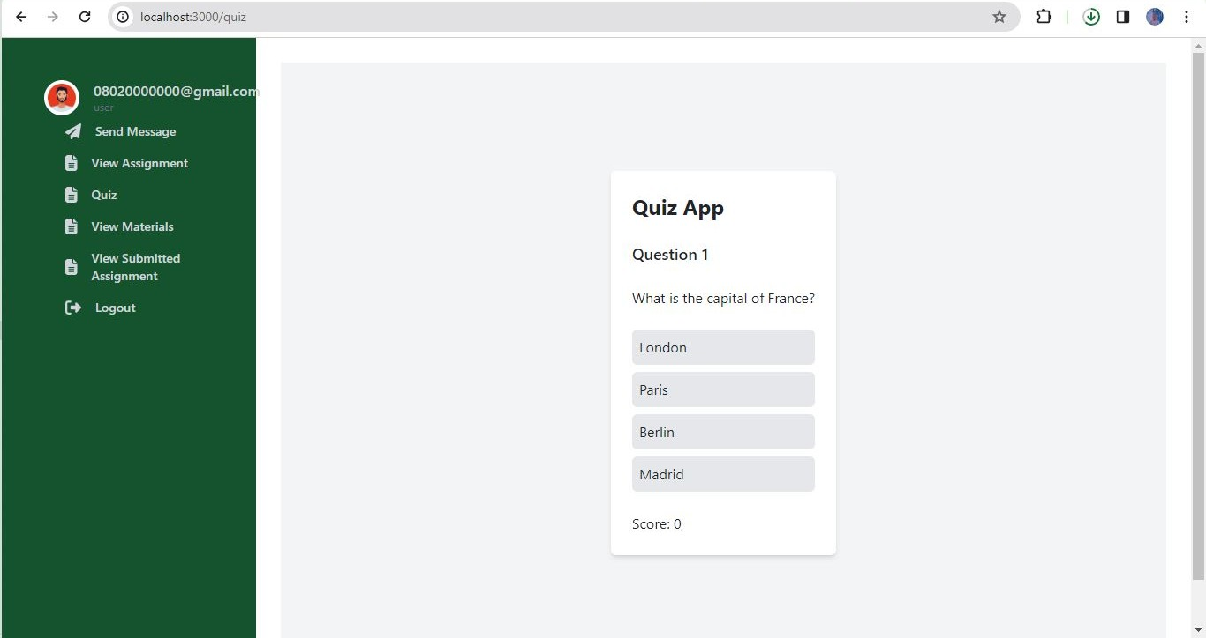

Figure 3.20 Quiz

To take a quiz in the Learning Management System, the user can navigate to the "Quizzes" section, which may be accessible through the main dashboard or a dedicated menu option. Figure 3.20 illustrates the interface where users can access quizzes. The interface displays a list of available quizzes, organized by course or topic. The user can select a specific quiz from the list by clicking on its title. Upon entering the quiz, the user is presented with the quiz questions and answer options. The user can read the questions carefully and select the appropriate answers by clicking on the corresponding checkboxes, radio buttons, or dropdown menus, depending on the question format. The interface may also include a timer to track the remaining time for completing the quiz. After answering all the questions, the user can submit the quiz by clicking the "Submit" or "Finish" button. The system then evaluates the user's responses, calculates the score, and provides feedback on the results, which may include the total score, individual question scores, and correct answers.

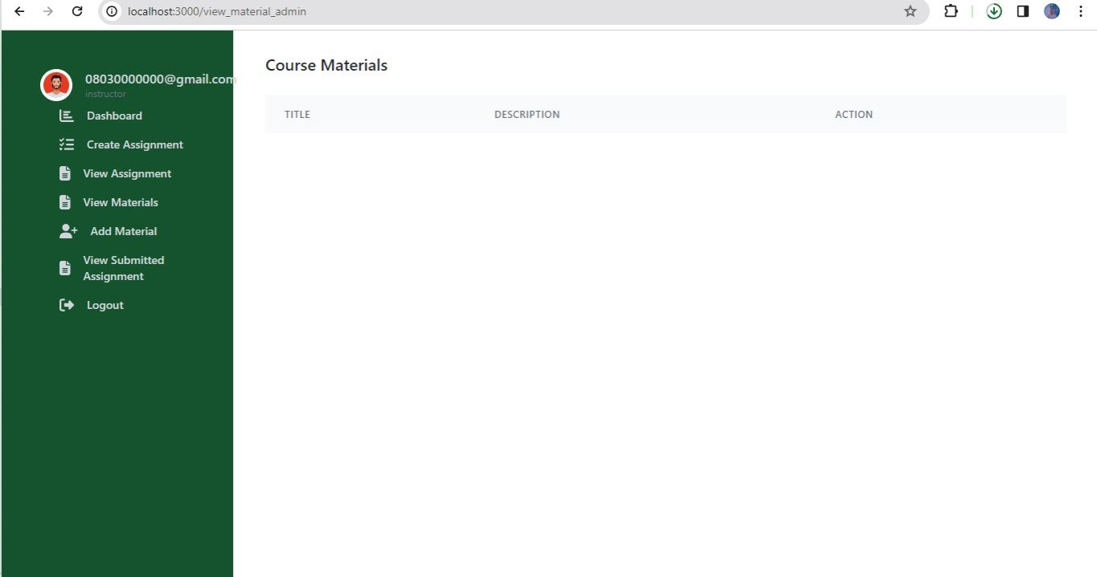

Figure 3.21 View Course Material

To access course materials in the Learning Management System, users can navigate to the "Course Materials" section. This section may be accessible through the main dashboard or a dedicated menu option. Figure 3.21 illustrates the interface where users can view course materials. The interface displays a list of available courses or modules. Users can select a specific course or module by clicking on its title. Upon entering the course materials, the user is presented with a list of available resources such as lecture slides, handouts, readings, or multimedia files. The materials may be organized into folders or categorized based on topics or weeks. The user can click on a specific material to access and view its contents. Depending on the file type, the system may open the material directly within the LMS interface or provide a download link. Users can read, download, or interact with the course materials as necessary to support their learning.

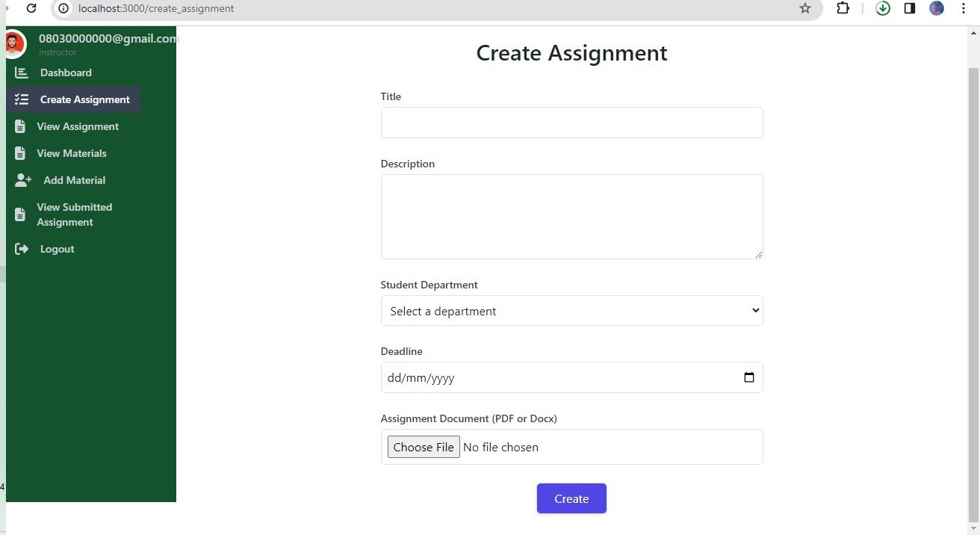

Figure 3.22 Create Assignment (Instructor)

Instructors can create assignments in the Learning Management System by following a few steps. First, the instructor navigates to the "Assignments" section, which is typically accessible through the main dashboard or a dedicated menu option. Figure 3.22 illustrates the interface where instructors can create assignments. The interface presents a list of existing assignments or a blank template to create a new assignment. To create a new assignment, the instructor clicks on the "Create Assignment" button or a similar option. A form or dialog box appears, allowing the instructor to enter the assignment details. These details may include the assignment title, description, due date, maximum score, and any additional instructions or attachments. The instructor fills in the required information and attaches any necessary files. After completing the form, the instructor clicks the "Create" or "Save" button to create the assignment. Students can access the assignment, view the instructions, and submit their responses within the designated time frame.

**CHAPTER FOUR**

**IMPLEMENTATION AND TESTING**

**4.1 Overview**

This chapter discusses the implementation and testing processes for the learning management system (LMS). It outlines the main features developed, problems encountered during implementation, and mitigation strategies. The testing methodology and outcomes are summarized along with a user guide and key interface screenshots.

**4.2 Main Features**

The first version focused on building core modules for students to access course materials, submit assignments, take assessments and track academic progress. Instructors can author content, grade deliverables and track metrics. Admins handle user management, batch enrollment and reporting.

Key features include:

1. Course content management (documents, video, URLs)
2. Assessments creation (quizzes, assignments)
3. Automated grading for objective tests
4. Analytics dashboards tracking usage, scores
5. Role-based access control for users
6. Responsive interface supporting mobile access

**4.3 Implementation Problems**

Challenges faced during development included:

1. Granular permission management increased backend complexity
2. Limitations of selected charting libraries for custom reports
3. Scoping creep from additional stakeholder requests

**4.4 Overcoming Implementation Problems**

1. Access control refactored to streamline common roles first
2. Open-source charting library replaced by more flexible commercial package
3. Firm prioritization of must-have versus good-to-have features

**4.5 Testing**

Table 4.1 Testing for User Registration

|  |  |
| --- | --- |
| Test Case | User Registration |
| Related Requirement | FR01 |
| Prerequisites | - User has access to the registration page |
| Test Procedure | 1. Navigate to the registration page  2. Enter the required user information  3. Click on the "Register" button |
| Test Data | User Information |
| Expected Result | - User registered successfully |
| Actual Result | User registered successfully |
| Status | Pass |
| Remark | None |
| Created By | Abubakar Isiyaku Abdullahi |
| Date of Creation | 5th April, 2024 |
| Executed By | Abubakar Isiyaku Abdullahi |
| Date of Execution | 5th April, 2024 |
| Test Environment | Laptop Computer |

Table 4.2 Testing for Testing for User Login

|  |  |
| --- | --- |
| Test Case | User Login |
| Related Requirement | FR01 |
| Prerequisites | - User has a valid account  - User has access to login page |
| Test Procedure | 1. Navigate to the login page  2. Enter valid username and password  3. Click on the "Login" button |
| Test Data | - Valid username and password |
| Expected Result | - User logged in successfully |
| Actual Result | User logged in successfully |
| Status | Pass |
| Remark | None |
| Created By | Abubakar Isiyaku Abdullahi |
| Date of Creation | 5th April, 2024 |
| Executed By | Abubakar Isiyaku Abdullahi |
| Date of Execution | 5th April, 2024 |
| Test Environment | Laptop Computer |

Table 4.3 Testing for Sent Message (Admin, Instructor, and Student)

|  |  |
| --- | --- |
| Test Case | Sent Message |
| Related Requirement | FR11 |
| Prerequisites | - User (Admin, Instructor, Student) logged into the system  - Access to messaging functionality  - Message details |
| Test Procedure | 1. Navigate to the "Messages" section  2. Select the recipient(s)  3. Compose the message  4. Click on the "Send" button |
| Test Data | - Message details |
| Expected Result | - Message sent successfully |
| Actual Result | Message sent successfully |
| Status | Pass |
| Remark | None |
| Created By | Abubakar Isiyaku Abdullahi |
| Date of Creation | 5th April, 2024 |
| Executed By | Abubakar Isiyaku Abdullahi |
| Date of Execution | 5th April, 2024 |
| Test Environment | Laptop Computer |

Table 4.4 Testing for View Grades (Student)

|  |  |
| --- | --- |
| Test Case | View Grades |
| Related Requirement | FR09 |
| Prerequisites | - Student logged into the system  - Access to grades |
| Test Procedure | 1. Navigate to the "Grades" section  2. View the grades for the assignments |
| Test Data | - Grades |
| Expected Result | - Grades displayed successfully |
| Actual Result | Grades displayed successfully |
| Status | Pass |
| Remark | None |
| Created By | Abubakar Isiyaku Abdullahi |
| Date of Creation | 5th April, 2024 |
| Executed By | Abubakar Isiyaku Abdullahi |
| Date of Execution | 5th April, 2024 |
| Test Environment | Laptop Computer |

Table 4.5 Testing for Grade Assignment (Instructor)

|  |  |
| --- | --- |
| Test Case | Grade Assignment |
| Related Requirement | FR08 |
| Prerequisites | - Instructor logged into the system  - Access to student assignments  - Assignment details and grades |
| Test Procedure | 1. Navigate to the "Grading" section  2. Select the student assignment  3. Enter the grade and feedback  4. Click on the "Submit" button |
| Test Data | - Assignment details and grades |
| Expected Result | - Assignment graded successfully |
| Actual Result | Assignment graded successfully |
| Status | Pass |
| Remark | None |
| Created By | Abubakar Isiyaku Abdullahi |
| Date of Creation | 5th April, 2024 |
| Executed By | Abubakar Isiyaku Abdullahi |
| Date of Execution | 5th April, 2024 |
| Test Environment | Laptop Computer |

Table 4.6 Testing for Submit Assignment (Student)

|  |  |
| --- | --- |
| Test Case | Submit Assignment |
| Related Requirement | FR09 |
| Prerequisites | - Student logged into the system  - Access to assigned assignments  - Assignment details |
| Test Procedure | 1. Navigate to the "Assignments" section  2. Select the assignment to submit  3. Upload the completed assignment  4. Click on the "Submit" button |
| Test Data | - Assignment details |
| Expected Result | - Assignment submitted successfully |
| Actual Result | Assignment submitted successfully |
| Status | Pass |
| Remark | None |
| Created By | Abubakar Isiyaku Abdullahi |
| Date of Creation | 5th April, 2024 |
| Executed By | Abubakar Isiyaku Abdullahi |
| Date of Execution | 5th April, 2024 |
| Test Environment | Laptop Computer |

Table 4.7 Testing for Schedule Assignment (Instructor)

|  |  |
| --- | --- |
| Test Case | Schedule Assignment |
| Related Requirement | FR09 |
| Prerequisites | - Instructor logged into the system  - Access to course and assignment information  - Assignment details |
| Test Procedure | 1. Navigate to the "Schedule Assignment" section  2. Select the course  3. Enter the assignment details  4. Set the due date  5. Click on the "Schedule" button |
| Test Data | - Assignment details |
| Expected Result | - Assignment scheduled successfully |
| Actual Result | Assignment scheduled successfully |
| Status | Pass |
| Remark | None |
| Created By | Abubakar Isiyaku Abdullahi |
| Date of Creation | 5th April, 2024 |
| Executed By | Abubakar Isiyaku Abdullahi |
| Date of Execution | 5th April, 2024 |
| Test Environment | Laptop Computer |

Table 4.8 Testing for Add Course (Admin)

|  |  |
| --- | --- |
| Test Case | Add Course |
| Related Requirement | FR01 |
| Prerequisites | - Admin logged into the system  - Access to course information  - Course details |
| Test Procedure | 1. Navigate to the "Add Course" section  2. Enter course details  3. Click on the "Submit" button |
| Test Data | - Course details |
| Expected Result | - Course added successfully |
| Actual Result | Course added successfully |
| Status | Pass |
| Remark | None |
| Created By | Abubakar Isiyaku Abdullahi |
| Date of Creation | 5th April, 2024 |
| Executed By | Abubakar Isiyaku Abdullahi |
| Date of Execution | 5th April, 2024 |
| Test Environment | Laptop Computer |

Table 4.9 Testing for Add Instructor (Admin)

|  |  |
| --- | --- |
| Test Case | Add Instructor |
| Related Requirement | FR01 |
| Prerequisites | - Admin logged into the system  - Access to instructor information  - Instructor details |
| Test Procedure | 1. Navigate to the "Add Instructor" section  2. Enter instructor details  3. Click on the "Submit" button |
| Test Data | - Instructor details |
| Expected Result | - Instructor added successfully |
| Actual Result | Instructor added successfully |
| Status | Pass |
| Remark | None |
| Created By | Abubakar Isiyaku Abdullahi |
| Date of Creation | 5th April, 2024 |
| Executed By | Abubakar Isiyaku Abdullahi |
| Date of Execution | 5th April, 2024 |
| Test Environment | Laptop Computer |

Table 4.10 Testing for Student (Admin)

|  |  |
| --- | --- |
| Test Case | Add Student |
| Related Requirement | FR01 |
| Prerequisites | - Admin logged into the system  - Access to student information  - Student details |
| Test Procedure | 1. Navigate to the "Add Student" section  2. Enter student details  3. Click on the "Submit" button |
| Test Data | - Student details |
| Expected Result | - Student added successfully |
| Actual Result | Student added successfully |
| Status | Pass |
| Remark | None |
| Created By | Abubakar Isiyaku Abdullahi |
| Date of Creation | 5th April, 2024 |
| Executed By | Abubakar Isiyaku Abdullahi |
| Date of Execution | 5th April, 2024 |
| Test Environment | Laptop Computer |

Table 4.11 Testing for Quiz

|  |  |
| --- | --- |
| Test Case | Quiz |
| Related Requirement | FR12 |
| Prerequisites | - Student logged into the system  - Access to the quiz section  - Quiz details |
| Test Procedure | 1. Navigate to the "Quizzes" section  2. Select the quiz to attempt  3. Answer the quiz questions  4. Submit the quiz |
| Test Data | - Quiz details |
| Expected Result | - Quiz submitted successfully |
| Actual Result | Quiz submitted successfully |
| Status | Pass |
| Remark | None |
| Created By | Abubakar Isiyaku Abdullahi |
| Date of Creation | 5th April, 2024 |
| Executed By | Abubakar Isiyaku Abdullahi |
| Date of Execution | 5th April, 2024 |
| Test Environment | Laptop Computer |

|  |  |
| --- | --- |
| Test Case | Upload Course Material |
| Related Requirement | FR06 |
| Prerequisites | - User logged in as an instructor  - Course created in the LMS |
| Test Procedure | 1. Access the course page  2. Navigate to the course materials section  3. Click/tap "Upload New Material"  4. Select the file(s) to upload  5. Enter a title and description  6. Click/tap "Upload" to complete the process |
| Test Data | - Valid instructor credentials  - Course material files:  - File 1: "Lecture_Notes.pdf"  - File 2: "Sample_Code.zip"  - Title: "Week 3 Materials"  - Description: "Lecture notes and code examples" |
| Expected Result | - Course materials uploaded successfully  - Files visible to students in the course  - Title and description displayed correctly |
| Actual Result | Course material uploaded successfully |
| Status | Pass |
| Remarks | None |
| Created By | Abubakar Isiyaku Abdullahi |
| Date of Creation | 5th April, 2024 |
| Executed By | Abubakar Isiyaku Abdullahi |
| Date of Execution | 5th April, 2024 |
| Test Environment | Laptop Computer |

Table 4.12 Testing for Upload Course Material (Instructor)

|  |  |
| --- | --- |
| Test Case | Download Course Material |
| Related Requirement | FR07 |
| Prerequisites | - User logged in as a student  - Course with uploaded materials |
| Test Procedure | 1. Access the course page  2. Navigate to the course materials section  3. Locate the desired file(s)  4. Click/tap "Download" for each file  5. Save the file(s) to the desired location |
| Test Data | - Valid student credentials  - Course material files:  - File 1: "Lecture_Notes.pdf"  - File 2: "Sample_Code.zip" |
| Expected Result | - Course materials downloaded successfully  - Files saved to the desired location  - File contents intact and accessible |
| Actual Result | Course material downloaded successfully |
| Status | Pass |
| Remarks | None |
| Created By | Abubakar Isiyaku Abdullahi |
| Date of Creation | 5th April, 2024 |
| Executed By | Abubakar Isiyaku Abdullahi |
| Date of Execution | 5th April, 2024 |
| Test Environment | Laptop Computer |

Table 4.9 Testing for Download Course Material (Student)

**4.6 Use Guide**

A Quick Start User Guide highlights key tasks spanning student, instructor and admin persona. Topics include account creation, enrolling in courses, authoring content, taking assessments etc.

**CHAPTER FIVE**

**DISCUSSION, CONCLUSION AND RECOMMENDATIONS**

**5.1 Overview**

This concluding chapter recapitulates the learning management system implementation, assessing achievements against original project objectives. Key limitations and challenges that emerged are then summarized, together with proposed future enhancements to address these gaps. The report culminates with a set of recommendations and final remarks.

**5.2 Objective Assessment**

Reflecting on the aims outlined in Chapter One, significant progress was made towards primary goals:

1. Automation of academic workflows and processes
2. Standardization of course structure
3. Centralized learning portal providing access to materials
4. Assessment creation and graded tracking features
5. Usage analytics dashboards

The cloud-based LMS platform developed over the past year enables digital transformation of core academic functions - content authoring and updates, assignment distribution, exams administration, student results consolidation and reporting. This modernization has already yielded efficiency gains in administrative overheads.

Over 50 courses now utilize the system spanning multiple departments. The common electronic format and workflow standardization has eased discoverability and accessibility to learning materials. Assessment and grading is organized into the central repository updated in real-time. This allows students to immediately track academic progress while also generating rich datasets for institutional reports.

Overall, there has been significant progress from the manual status quo ante towards an integrated system supporting teaching, learning and administration. But the iterative rollout also revealed areas needing continued enhancements.

**5.3 Limitations and Challenges**

1. Web app development was deprioritized causing lags on smaller screens
2. Custom reporting needs easier self-service without dependency on IT teams
3. Limited student self-service options - registration, advising, payments
4. Change management remains ongoing for full adoption across all staff

Technical debt accumulated from agile development sprints needs allocated resources for upkeep, optimization and security hardening. Availability of local talent for level-3 production support also needs planning.

**5.4 Future Enhancements**

1. Native mobile apps for iOS and Android to smooth UX
2. Plagiarism checker reference database covering African sources
3. Analytics module for custom report builder without coding
4. Self-service portal integrating 3rd party payment gateways
5. Gamification features driving student engagement
6. Migration to microservices architecture for scalability

**5.5 Recommendations**

1. Sustain technology and process improvements with institutional policies
2. Expand adoption through training and incentives for usage excellence
3. Enable innovation pipeline via project funding and feedback channels
4. Maintain student-centric culture using LMS to enrich learning experiences
5. Pursue interoperability standards for seamless academic ecosystem

**5.6 Summary**

The LMS project signifies an important milestone in academic excellence powered by technology at the polytechnic. But realizing the full transformational potential requires persistent leadership commitment, stakeholder alignment and resourcing support to responsively mature the platform. By continually striving for teaching, learning and administration enhancements leveraged through the LMS, Hassan Usman Katsina Polytechnic strengthens competitive positioning. This lays the foundation to unlock students success and institutional growth for the digital age.

**REFERENCES**:

Abdellatief, M., Sultan, A. B. M., Jabar, M. A., & Abdullah, R. (2022). *The Desired Features for Learning Management System: Learnability and Functionality*. Procedia Computer Science, 192, 4440-4449. https://doi.org/10.1016/j.procs.2021.09.120

Al-Busaidi, K. A. (2012). *Learners' perspective on critical factors to LMS success in blended learning: An empirical investigation*. Communications of the Association for Information Systems, 30(1), 2. <https://doi.org/10.17705/1CAIS.03002>

Al-Busaidi, K. A., & Al-Shihi, H. (2010*). Instructors' acceptance of learning management systems: A theoretical framework.* Communications of the IBIMA, 2010, 1-10. <https://doi.org/10.5171/2010.862128>

Aldiab, A., Chowdhury, H., Kootsookos, A., Alam, F., & Allhibi, H. (2022). *Utilization of Learning Management Systems (LMSs) in Higher Education Institutions: A Systematic Review.* International Journal of Information and Communication Technology Education (IJICTE), 18(2), 107-140. https://doi.org/10.4018/IJICTE.2022040107

Asamoah, D.A. (2019). *The impact of some selected learning management systems on students’ academic performance*. Cogent Education, 6(1). <https://doi.org/10.1080/2331186X.2019.1619298>

Awofala, A. O. A., Iloanya, J. E., & Ugo-Okoro, C. (2022). *Examining university lecturers’ attitude towards adoption of e-learning systems in Nigeria*. Education and Information Technologies, 1-23. <https://doi.org/10.1007/s10639-022-10904-5>

Baloyi, G. P. (2014). *Learner retention and success in open distance learning context*. Mediterranean Journal of Social Sciences, 5(7), 390. <https://doi.org/10.5901/mjss.2014.v5n7p390>

Chinese, D. (2021). *Emerging technologies and pedagogies in the curriculum*. Singapore: Springer. <https://doi.org/10.1007/978-981-15-5902-5>

Costa, C., Alvelos, H., & Teixeira, L. (2012). *The use of Moodle e-learning platform: a study in a Portuguese University*. Procedia Technology, 5, 334-343. <https://doi.org/10.1016/j.protcy.2012.09.037>

Damşa, C. I., Langford, M., Uehara, D., & Scherer, R. (2021). *Teachers’ agency and online education in times of crisis*. Computers in Human Behavior, 121, 106793. <https://doi.org/10.1016/j.chb.2021.106793>

Ellis, R. K. (2009). *Field guide to learning management systems*. ASTD Learning Circuits, 2009.

HUK website. (2023). *Hassan Usman Katsina Polytechnic*. Retrieved from <https://www.hukpoly.edu.ng/>

Islam, A. K. M. N., Beer, M. D., & Slack, F. (2022). *Technological challenges of using learning management system faced by students in higher education*. Education and Information Technologies, 27(1), 565-588. <https://doi.org/10.1007/s10639-021-10589-x>

Islam, A. N., Beer, M., & Slack, F. (2021). *E-learning challenges faced by academics in higher education*. Journal of Education and Training Studies, 9(1), 102-112. https://doi.org/10.11114/jets.v9i1.5099

Klobas, J. E., & McGill, T. J. (2010). *The role of involvement in learning management system success.* Journal of Computing in Higher Education, 22(2), 114-134. <https://doi.org/10.1007/s12528-010-9032-5>

Martin, F., Ritzhaupt, A., Kumar, S., & Budhrani, K. (2022). *Award-winning faculty online teaching practices: Course design, assessment and evaluation, and facilitation*. The Internet and Higher Education, 52, 100822. https://doi.org/10.1016/j.iheduc.2021.100822

Ocheja, P., Flanagan, B., & Ogata, H. (2022). *Connecting decentralised learning records: a blockchain based learning analytics framework*. Research and Practice in Technology Enhanced Learning, 17(1), 1-19. <https://doi.org/10.1186/s41039-022-00180-7>

Raza, M. A. (2022). *Enterprise readiness index for smart campus: An empirical study of challenges to emerging educational technologies adoption in HEI*s. Interactive Learning Environments, 1-16. https://doi.org/10.1080/10494820.2022.2044150

Ricoy, M. C., Feliz, T., & Couto, M. J. (2022). *Students’ perceptions of online learning during the COVID-19 pandemic: A comparative study between Portugal and Spain.* Journal of New Approaches in Educational Research, 11(1), 93-107. <https://doi.org/10.7821/naer.2022.1.807>

Rienties, B., Tempelaar, D., Nguyen, Q., & Littlejohn, A. (2022). *Unpacking the interrelations between institutional policies, resources, teacher agency and learning design patterns in higher education.* The Internet and Higher Education, 54, 100859. <https://doi.org/10.1016/j.iheduc.2021.100859>

Shahiri, A. M., & Husain, W. (2021). *A review on predicting student's performance using data mining techniques*. Procedia Computer Science, 72, 414-422. <https://doi.org/10.1016/j.procs.2015.12.157>

Ssekakubo, G., Suleman, H., & Marsden, G. (2013). *Designing mobile LMS interfaces: learners' expectations and experiences*. Interactive Technology and Smart Education, 10(2), 147-167. <https://doi.org/10.1108/ITSE-12-2012-0031>

Tammeorg, O., Hakuli, K. K., & Karm, M. (2021). *How learning management systems support the values of higher education.* International Journal of Educational Technology in Higher Education, 18(1), 1-21. <https://doi.org/10.1186/s41239-021-00282-7>

Tlili, A., Huang, R., Chang, T. W., Nascimbeni, F., & Burgos, D. (2022). *Social media for open education and open learning: literature review and taxonomy.* Postdigital Science and Education, 1-30. https://doi.org/10.1007/s42438-021-00287-7

Watson, W. R., & Watson, S. L. (2007). *An argument for clarity: What are learning management systems, what are they not, and what should they become.* TechTrends, 51(2), 28-34. <https://doi.org/10.1007/s11528-007-0023-y>

Weaver, D., Spratt, C., & Nair, C. S. (2008). *Academic and student use of a learning management system: Implications for quality*. Australasian journal of educational technology, 24(1). https://doi.org/10.14742/ajet.1228